Radio Frequency Energy Harvester

Joshlyn Richter

Mojtaba Alhudibi

Mohammed Aljubara

Academic Advisor: Khair Al Shamaileh

Departments of Engineering

##### **College of Engineering and Science**

Purdue University Northwest

##### **December 6, 2016**

Executive summary

The modern world is permeated by radio frequency (RF) energy. This energy is used to transmit and receive all types of information from television, Internet, text, and telephone. While this energy is always present and ready for use, the majority of it will never be used. RF energy harvesting is a method of converting this ambient radio frequency energy in the atmosphere into a DC voltage, which can be used to power small electrical circuits and devices. Using RF energy harvesting allows the possibility to constantly power those small circuits wirelessly which permits them to be used in places and applications that were normally not feasible. The use of RF energy harvesting not only reduces the need for environmentally hazardous materials like batteries and wires, but also decreases the need to power devices that require a constant, uninterrupted, power source which will not emit Carbon Dioxideand other harmful substances into the environment. This paper will focus on the methods used to convert Radio frequency energy into a usable DC voltage. Determine what frequencies would be best to use when attempting to harvest radio frequency energy, designing antennas to receive the correct radio frequency and how to match the impedance of the circuits inside the energy harvester to maximize the efficiency of the RF energy harvesting circuit. The frequencies from which the project would harvest the energy were chosen to be 0.8 GHz and 2.1 GHz. The reason of choosing these two frequencies was that the antenna was designed to be a dual band antenna, also those frequencies are within the range of frequencies covered by the cellular network providers such as AT&T and T-Mobile. After the antenna part was done, the design and simulation of the Villard multiplier circuit that would convert the received Radio Frequency to a usable Direct Current signal was implemented. Finally all parts were fabricated and printed on a Printed Circuit Board and assembled together. The assembled project components were able to harvest energy from the Radio Frequency in the atmosphere and provide output power.

**Abstract**

Recent innovation technology allow the fast reduction in both size and power consumption of conventional digital systems currently powered by batteries. However, batteries introduce several disadvantages as they need to either be recharged or replaced periodically. Moreover, their size and weight are large compared to high-technology electronics. The size of the electronic circuit has been drastically reduced during recent decades. Together with this trend, the supply voltage has also decreased. The requirement for new alternatives to extract energy from the environment and transform it to electrical energy to power an electronic device has grown. Currently extensive research is available investigating a number of energy harvesting resources. In this report a single dipole antenna was designed and utilize to operate at 0.8GHz using HFSS High Frequency Structural Simulator. Then, to improve energy harvesting capability, a spiral antenna was designed to function at two different frequency’s 0.8GHz and 2.1GHz. In order to be able to use the harvested signal, it needs to be converted into an amplified DC signal. For that reason, the Villard Multiplier circuit was chosen because it does the rectification of RF AC signal to a DC signal and amplifies it at the same time. A two-stage and four-stage half wave Villard multiplier circuit were selected for this part. In the Villard circuit, Schottky diode HSMS-2850 was used because of its fast switching ability and it handles RF small signals very well. After the analysis was done using Ansys Designer for Villard and Ansys HFSS for the antenna, both were needed to fabricated and printed on a PCB board. However, the manufacturers that were contacted for the fabrication requested a file format the Ansys does not export. Ansys exports aebt and cad while the manufacturers required gerber files in order to do the fabrication. For that reason, the open source software Kicad was used to redraw both the antenna and the Villard circuit, exported to gerber files, and then sent for fabrication. After receiving the PCBs, the parts were soldered in the school’s shop using leaded solder past. Both the antenna and the Villard were tested at Purdue university Northwest – Westville campus using both spectrum analyzer for the antenna and the function generator for the Villard circuit.

**Table of Contents**

|  |  |
| --- | --- |
| Introduction.  Background.  Objectives.  Constrains.  Environmental Impact.  Approach.  Antenna Design, Analysis, and Optimization.  Design process.  Analysis and Optimization.  Improving.  Villard Multiplier Circuit.  Matching Circuit.  Fabrication.  Testing and Results.  Conclusion and future work.  References.  Appendix. | 1  2  2  2  2  3  5  5  8  11  16  22  23  26  31  32  33 |

**List of Figures**

|  |  |
| --- | --- |
| Figure 1. Conceptual block diagram for RF energy harvesting system.  Figure 2. The design of Dipole micro-strip antenna.  Figure 3. The pole and feeding arm dimensions.  Figure 4. Input Port matching analysis.  Figure 5. Optimized Design.  Figure 6. Optimization with fixed ground dimensions.  Figure 7. Optimization with fixed ground length = 50mm.  Figure 8. Optimization sweeping the groung width value.  Figure 9. Dual-band Spiral monopole antenna.  Figure 10. Input port matching for dual band antenna.  Figure 11. Antenna impedance at 0.8 GHz.  Figure 12. Antenna impedance at 2.1 GHz.  Figure 13. The 3D gain at 0.8GHz.  Figure 14. The 3D gain at 2.1GHz.  Figure 15. The 2D radiation field at 0.8GHz.  Figure 16. The 2D radiation field at 2.1GHz.  Figure 17. Two-Stage half-wave Villard Multiplier Circuit.  Figure 18. Two-Stage full-wave Villard Multiplier Circuit.  Figure 19. Two-Stage half-wave Villard Multiplier Circuit simulation results.  Figure 20. Two-Stage full-wave Villard Multiplier Circuit simulation results.  Figure 21. Single Stage half wave Villard Multiplier Circuit.  Figure 22. Single stage analysis at 0.8 GHz.  Figure 23. Single stage analysis at 2.1 GHz.  Figure 24. Two Stages half-wave Villard Multiplier.  Figure 25. Two stages analysis at 0.8 GHz.  Figure 26. Two stages analysis at 2.1 GHz.  Figure 27. Four Stages half-wave Villard Multiplier.  Figure 28. Four stages parametric analysis at 2.1 GHz.  Figure 29. Four stages analysis at 0.8 GHz.  Figure 30. Four stages final Villard multiplier optimized design.  Figure 31. Matching Circuit diagram.  Figure 32. Spiral Antenna in Kicad.  Figure 33. 2 stage Villard circuit PCB layout in Kicad.  Figure 34. A 3D model of 2 stage Villard Circuit in Kicad.  Figure 35. 4 stage Villard circuit PCB layout in Kicad.  Figure 36. A 3D model of 4 stage Villard Circuit in Kicad.  Figure 37. Spectrum Analyzer.  Figure 38. High Frequency Function Generator.  Figure 39. Antenna tested as transmitter at 1.8 GHz.  Figure 40. Antenna receiving signal at 820 MHz.  Figure 41. Antenna receiving signal at 1.87 GHz.  Figure 42. Antenna receiving signal at 2.39 GHz.  Figure 43. Two-stage at 800 MHz.  Figure 44. Two-stage at 2.1 GHz.  Figure 45. Two-stage at 2.28 GHz.  Figure 46. Two-stage at 2.36 GHz.  Figure 47. Four-stage at 1.499 GHz.  Figure 48. Four-stage at 2.1 GHz.  Figure 49. Four-stage at 2.25 GHz.  Figure 50. Four-stage at 2.37 GHz.  Figure 51. Four-stage at 2.44 GHz. | 1  5  6  7  8  9  9  10  11  12  12  13  13  14  14  15  16  16  17  17  18  18  19  19  20  20  20  21  21  21  22  23  24  24  24  25  26  26  27  27  28  28  29  29  29  29  29  29  30  30  30 |

|  |  |  |
| --- | --- | --- |
| **List of Tables**  Table 1. Power density available for a 50 kW AM radio station.  Table 2. Power density available for a 100 W GSM base station.  Table 3. Power density available for a 1W Wi-Fi router.  Table 4: Cellular Network Downlink Frequencies. |  | 3  3  4  6 |
|  |  |  |

Introduction

Energy Harvesting (EH), also known as power harvesting, is the process where the surrounding energy is collected by using Direct Energy Conversion and used to provide electrical power for small electronic and electrical devices. Energy-harvesting devices do not consume any fuel or substance but provide energy. A variety of techniques are available for energy scavenging. One of the sources of energy available in the environment is electromagnetic (EM) radiation. Most people do not realize that there is a plenty of energy all around us at all times. We are being bombarded with energy waves coming from cell phone towers, broadcast television signals, satellites orbiting earth, as well as wireless radio (Wi-Fi) networks, routers, wireless LANs (WLANs), fm/am radio signals and even portable communications devices like mobile phones. All of them transmit signals, combinations of energy and information, constantly. A radio frequency (RF) energy harvester gathers RF signals and coverts it into electricity. This significant amount of the radio frequency power in the form of electromagnetic (EM) waves in the environments gives us a high potential for RF energy harvesting systems. Technically, this free-flowing energy can be captured, converted and stored, for use in other applications. In fact, it can be utilized in a number of ultra-low-power, battery-free applications, such as Arduino boards, calculators and wireless sensor networks. As a result, different ideas for RF energy scavenging have been generated for a wide variety of applications, including portable devices, medical applications, and battery-charging system. While RF energy harvesting devices have benefits, they also have some disadvantages. One of the disadvantages of the system is that it depends location. Distance is an important limitation because the strength of radiation dissipates greatly with it. This report will discuss the use of a sing dipole antenna which will cover the frequency of 0.8GHz. Moving forward to improve the energy harvesting will be using a spiral antenna that cover the two targeted frequency’s 0.8GHz and 2.1GHz. The function block structure of the RF can be found in Figure1.

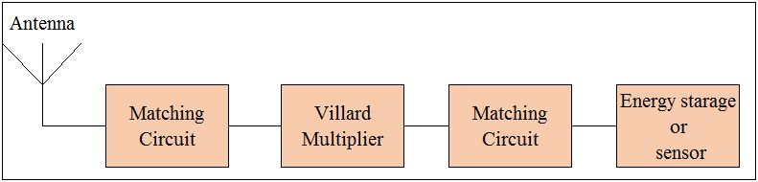

*Figure 1. Conceptual block diagram for RF energy harvesting system.*

Background

This work will introduce the concept of RF energy harvesting and illustrate the need for the system as well as the system components itself. Also, the steps used to design the antenna will be discussed as well as the simulation results and optimization. Furthermore, the design process and the analysis of the rectification part of the project will also be detailed. Finally, the fabrication and assembly work will be shown as well.

Objectives

The focus of this project is to design an antenna to receive the RF signals in the environment and fabricate a multiplier and matching circuit that will convert the electromagnetic energy received from the antenna into a DC voltage that has enough energy to power a low power device.

Constraints

The project faced three major constraints throughout its timeline. First, the Ansys software used to design the antenna could not export the design in any usable industrial format. To correct this issue a new software not available on campus was required and the antenna had to be redrawn from scratch before it could be exported in a Gerber cad format normally used in the printed circuit board (PCB) industry. This delayed the fabrication of the antenna and the testing of the Villard multiplier circuit. The second constraint was access to the required testing equipment. The main signal used to generate the DC voltage on the PCB ranges from approximately 700MHz to 2.5GHz and there was no equipment on campus able to perform these measurements. The equipment required to test the fabricated antenna and circuits was available at the Purdue University Westville Campus. Also no test probe was available for the spectrum analyzer, this limited the amount of measurements that could be performed and inhibited the analysis of the circuit. The third constraint occurred during the testing of the circuit at the Purdue University Westville campus. The connector on the PCB broke off and one of the pads on the PCB was also ripped off with the connector. While the board was fixed, the jumper wire used to pass the damaged pad and the lack of solder used in the repair gave concern about the accuracy of the measurements on the four-stage half-wave Villard multiplier circuit.

Environmental Impact

While the effects of radio frequency (RF) radiation on people and the environment are still being conducted, the RF energy harvester has no significant environmental impact because it only pulls energy from the environment, it doesn’t transmit any RF radiation. The only possible concern could be the effect the harvester has on the quality of cellular reception in the area it is operating.

Approach

The first thing that must be considered when harvesting energy is the source of the energy particularly where the energy source is located and the amount of energy available. When considering radio frequency (RF) energy there are many different options including radio, digital TV, cell phones, and Wi-Fi. to choose from. The power density and availability of the RF energy was considered in the tables below. Table 1 shows the power density in a given range for a 50 Kw AM radio station which usually operates between 540 KHz – 1600 KHz. Table 2 covers the power density and range for 100 W GSM stations which operate at 728 MHz to 894 MHz and 1930 MHz to 2155 MHz [1].

*Table 1. Power density available for a 50 kW AM radio station.*

|  |  |
| --- | --- |
| 50 kW AM Radio Station | |
| Distance | Power Density Available |
| 5 Km | 159 µW/m2 |
| 10 Km | 40 µW/m2 |

*Table 2. Power density available for a 100 W GSM base station.*

|  |  |
| --- | --- |
| 100W GSM Base Station | |
| Distance | Power Density available |
| 100 m | 800 µW/m2 |
| 500 m | 32 µW/m2 |
| 1000 m | 8 µW/m2 |

Even though the Wi-Fi signal has the most energy density, the range for Wi-Fi is very small and it is usually not readily available outside buildings (Table 3). When comparing AM radio frequencies and GSM frequencies, AM frequencies have an advantage in power and range over GSM frequencies. However, GSM frequencies require smaller antennas compared to AM frequencies and GSM signals are available nationwide while AM frequencies are usually only available in a particular regions. Using this information it was determined that GSM frequencies would be the ideal choice for RF energy harvesting due to availability in the local environment.

*Table 3. Power density available for a 1W Wi-Fi router.*

|  |  |
| --- | --- |
| 1 W Wi-Fi ROUTER | |
| DISTANCE | Power Density Available |
| 1 m | 80 mW/m2 |
| 5 m | 3.2 mW/m2 |
| 10 m | 0.8 mW/m2 |

This process will cover the design process details of the dipole micro-strip antenna and the parameters and dimensions chosen for the targeted frequency or frequencies. This part will also give the reasons of choosing certain values and parameters. In order to do the design and simulation process, Ansys Electronic Desktop 2016.1 was utilized to build an HFSS structure for the antenna. HFSS stands for *High Frequency Structural Simulator* and it is one of the commercial assets available in the market dedicated for the design and simulation of antennas and complex Radio Frequency circuits and elements including filters, packaging, and transmission lines. This part will go over the design of the first picked antenna and its optimization process which led later to the change of the antenna to improve efficiency and increase the potential amount of energy to be harvested. Next step was the design and analysis of the Villard Multiplier Circuit which is the amplifier part of the circuit. The Villard Circuit will rectify the received voltage and amplify it to a certain value simultaneously. The design and analysis of the Villard Circuit were done using Ansys Designer. The final steps were to fabricate and print the antenna and the Villard on a PCB, assemble the components, and test the whole harvester.

Antenna Design, Analysis, and Optimization

This part covers the process of designing the antenna as the first component required for the project. The layout of the antenna, type, dimensions, and material will be mentioned along with the analysis of the parameters used to make the antenna a whole. Phases of this part would be design process, analysis and optimization, and improving.

Design Process

Dipole micro-strip antenna consists of a substrate that has two printed poles and a ground. Each pole is printed on a side of the substrate directed in the opposite side of the other pole. The ground is a partial ground where it only covers part of one of the sides and merged with the pole on that side (Fig. 2). The reasons of choosing this type of antennas are the ability of receiving signal from almost all direction which means that they don’t have to be directed to the source in order to have a good reception, also they are easy to implement and fabricate.

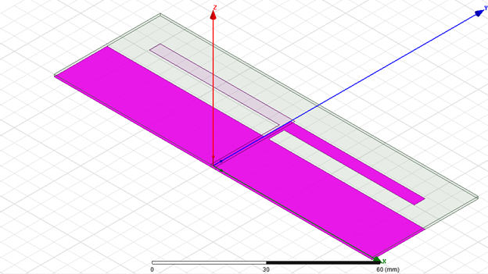

*Figure 2. The design of Dipole micro-strip antenna.*

The first design parameters were targeted for the antenna to operate at 0.8 GHz using a substrate of material R04003c with relative permittivity r = 3.55 and thickness of h = 0.813mm. The pole arm length of the antenna can be determined using the equation of the wave length:

$$λ=\frac{∁}{f\sqrt{εeff}}$$

Where $∁$ is the speed of light “300,000 Km/s”, f is the frequency, and eff is the effective permittivity of the substrate. The antenna arm length is going to be $\frac{λ}{4}$ as physical length which is equivalent to 90º electrical. The initial dimensions of the radiation part or the pole arm can be seen in Figure 3.

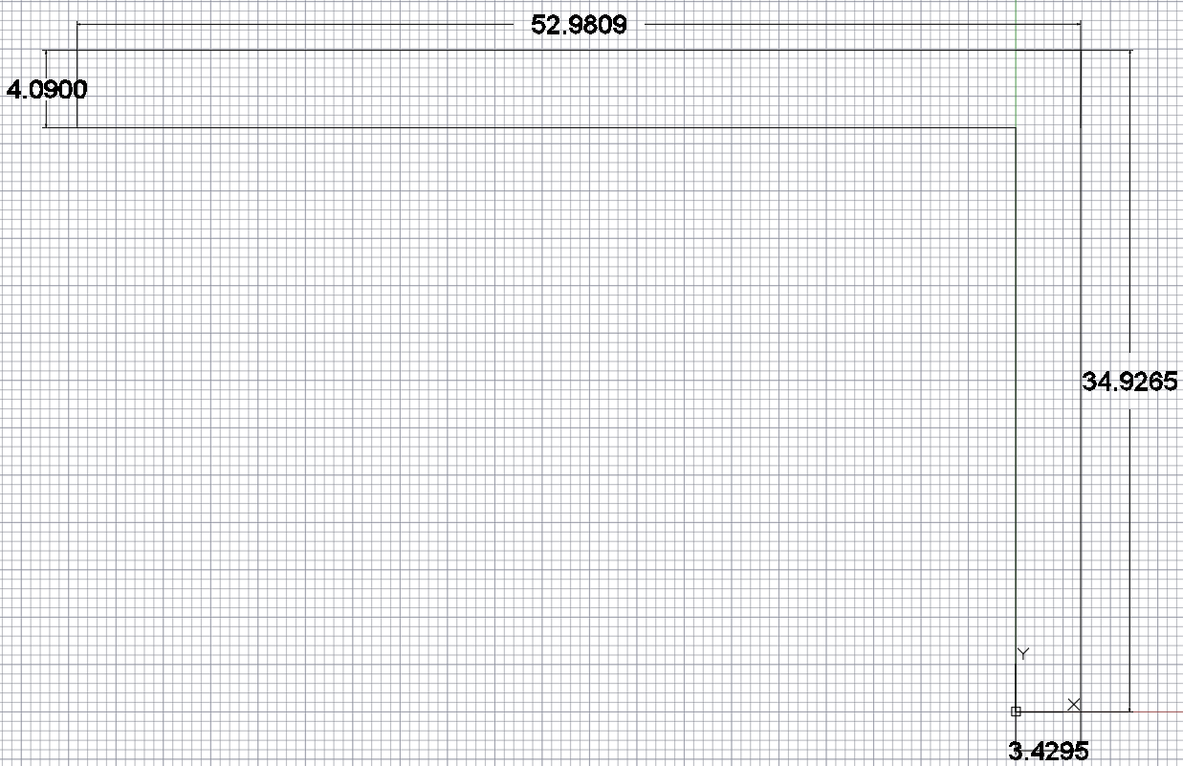

*Figure 3. The pole and feeding arm dimensions*.

The dipole antenna was designed basically to harvest energy from a single band frequency which is 0.8 GHz. This frequency band covers the 3G “3rd Generation” Wideband Code Division Multiple Access (WCDMA) cellular network signal. Table 4 shows the cellular network frequencies for different carriers in the United States categorized based on technologies 2G, 3G, and 4G.

*Table 4. Cellular Network Downlink Frequencies.*

|  |  |  |  |  |
| --- | --- | --- | --- | --- |
| Carrier  Technology  / Bandwidth | C:\Users\malhudib\Downloads\att_2016_logo_with_type.png | C:\Users\malhudib\Downloads\index.png | C:\Users\malhudib\Downloads\t-mobile-logo-tmobile.jpg | C:\Users\malhudib\Downloads\Screen_Shot_2015-09-02_at_2.20.55_pm.0.0.png |
| 2G | 1930 – 1995 MHz | | | |
| 3G | 869 – 894 MHz | | | |
| 4G | 728 – 757, 2110 – 2155 MHz | | | |

The reason for choosing the 3G WCDMA band for harvesting energy is that 3G is the most present and strongest signal in the ambient atmosphere surrounding us compared to 2G and 4G. The first simulation of the implemented design of the antenna in Ansys HFSS with the selected dimensions and parameters (Fig. 4).

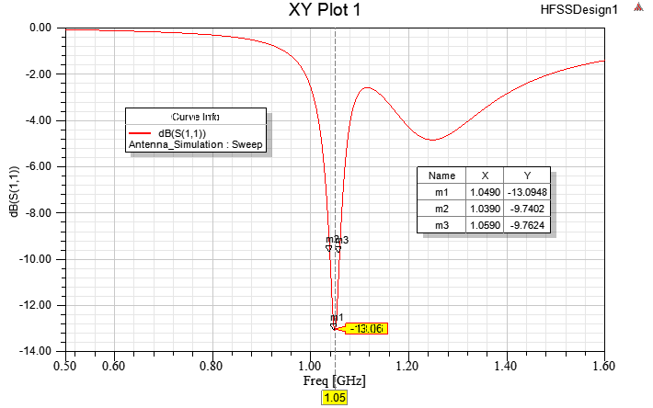

*Figure 4. Input Port matching analysis.*

The first results of HFSS simulation analysis show that the antenna would pass a good amount of energy, more than 90% of the signal it receives. The general accepted input port matching of any antenna is -10dB. To understand -10dB and how much that would be, the following equation of the input port matching would explain.

Ѕ11

Solving the equation for input port matching Ѕ11 will provide the result for Ѕ11= 0.1 W based on the values of the power that the antenna received of 1 W. The results were acceptable in general, but further optimization is required to improve the efficiency and increase the bandwidth as well.

Analysis and Optimization

In order to optimize the antenna to increase its efficiency and bandwidth, some of the antenna parameters and dimensions must be changed. The dimensions to be changed included the feeding- arm length, the ground width, and the ground length. Using HFSS actually makes it easy to do parametric analysis, which basically requires setting the value of the feeding arm, for example, to be a variable instead of a single value. That gives the software the ability to change the values of the feeding arm within a certain range of values with a certain step size. However, in order to cover the chosen range of values to do the parametric analysis, the substrate length had to change as well. Changes have been made to adapt to the optimization of the antenna, where the most noticeable difference is the arm length (Fig. 5).

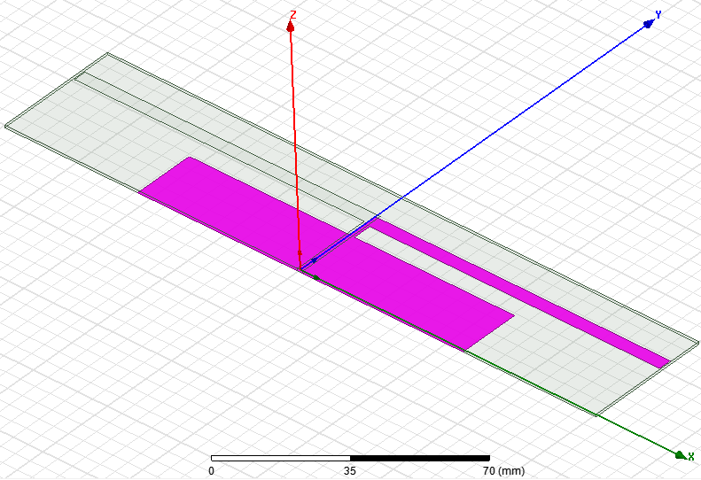

*Figure 5. Optimized Design.*

The type of the analysis used to optimize the antenna was parametric analysis. Parametric analysis changes predetermined variables within a selected range with defined step changes and includes the analysis of each change. The parameters used were the values of the arm length, ground width, and ground length. Figure 6 shows the results of a fixed value of ground width at 50mm and ground width at 20mm but changing arm length between 90mm and 98mm in steps of 2mm.

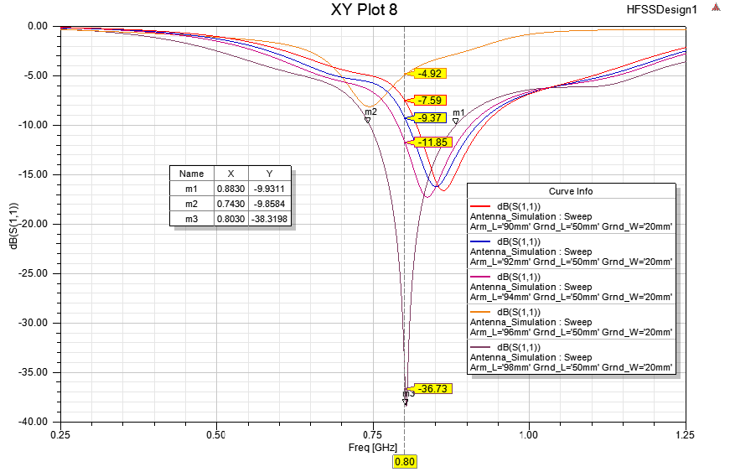

*Figure 6. Optimization with fixed ground dimensions.*

In Figure 7 optimization, keeping the values of the ground length fixed at 50mm , arm length at 98mm while sweeping the value of the ground width betwen 12mm and 20mm with step size of 2mm. It can be clearly noticed the affect of increasing the arm length causes the graph to shift to the right towards smaller frequencies.

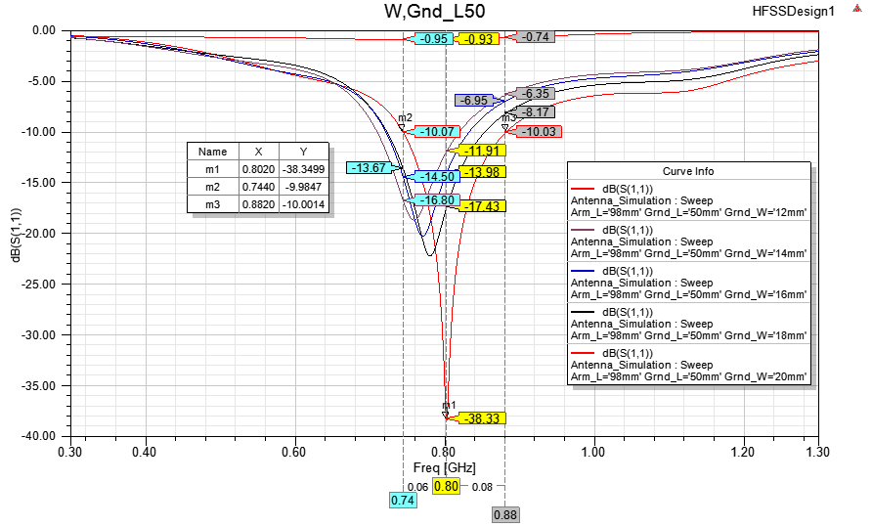

*Figure 7. Optimization with fixed ground length = 50mm.*

In Figure 8 optimization, keeping the values of the ground length fixed at 55mm , arm length at 98mm while sweeping the value of the ground width between 12mm and 20mm with step size of 2mm. The sweep of the ground lengeth affects the bandwidth of the received signal as it increased, bandwidth increased as well. It can be noticed that the change of the combination values between the ground width and ground length affeects the bandwidth and the effecincy of the received signal.

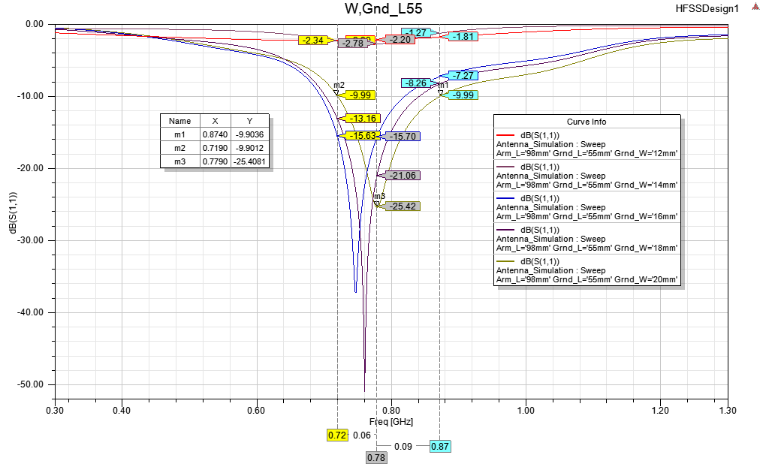

*Figure 8. Optimization sweeping the groung width value.*

Improving

In order to harvest more energy and more efficiently, the targeted antenna designed was switched from a single band to a dual-band antenna, specifically to harvest energy from 0.8 GHz, and 2.1 GHz which will cover both 3G WCDMA and 4G cellular signals as can be seen in table 1. Because of making such a change, the antenna is also changed from a dipole to a spiral monopole antenna that would harvest energy from dual bands. The substrate for the spiral monopole antenna is of type FR4 with relative permittivity r = 4.6 and thickness of h = 0.813mm. The final implemented design of the spiral monopole antenna can be seen in Figure 9.

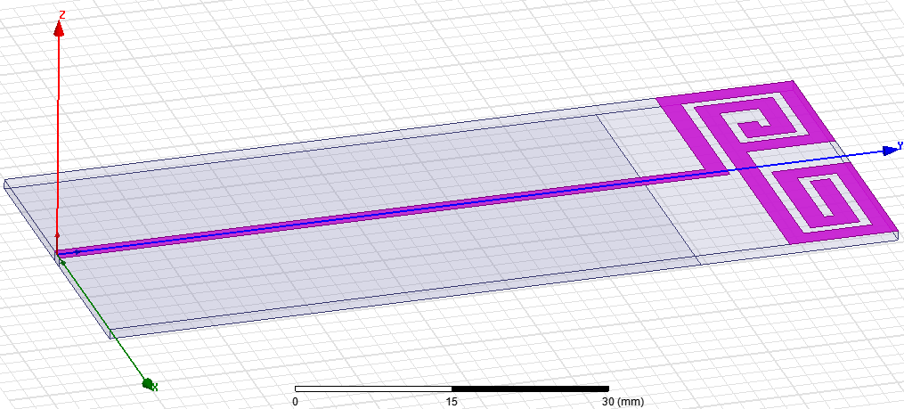

*Figure 9. Dual-band Spiral monopole antenna.*

The result of the analysis of the spiral monopole antenna in HFSS returned the input port matching values for both bands 0.8GHz and 2.1GHz in Figure 10.

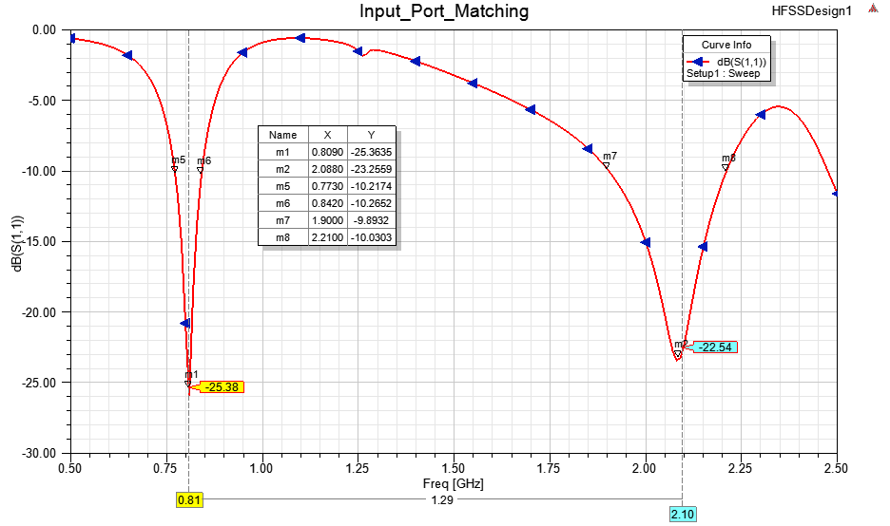

*Figure 10. Input port matching for dual band antenna.*

The impedance of the antenna can also be calculated and simulated in HFSS. In order to have a good and efficient antenna it has to have and impedance consist of 50Ω real part and 0Ω imaginary part. The impedance of the antenna both real and imaginary for both bands is illustrated in Figure 11 and Figure 12.

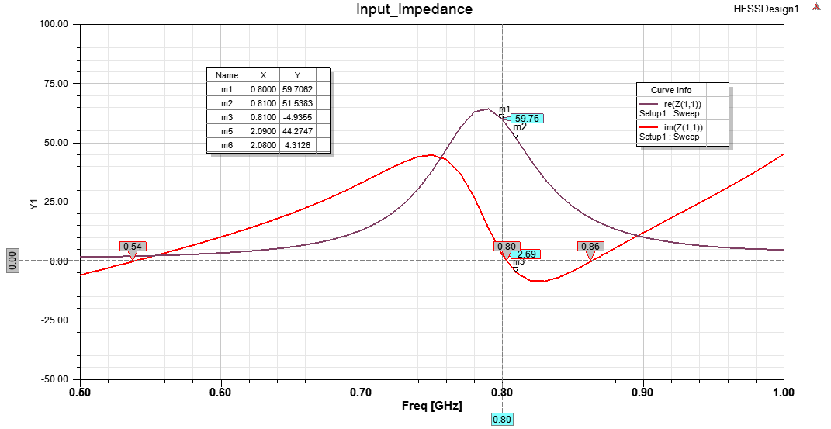

*Figure 11. Antenna impedance at 0.8 GHz.*

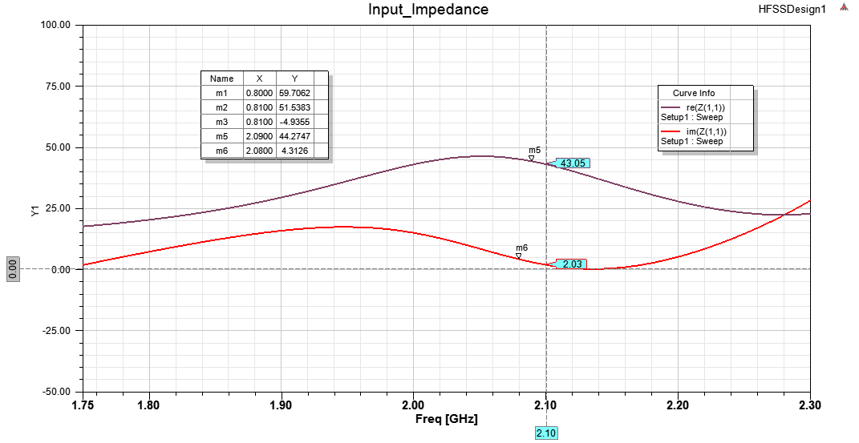

*Figure 12. Antenna impedance at 2.1 GHz.*

Doing further analysis on the antenna on HFSS to get the 3D gain and the 2D radiation field for both bands can be seen in Figure 13 and Figure 14.

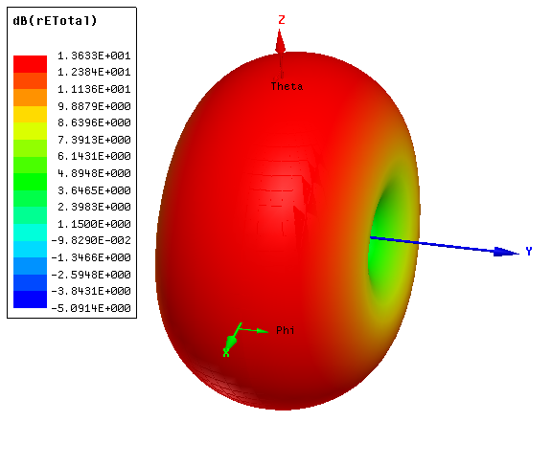

*Figure 13. The 3D gain at 0.8GHz.*

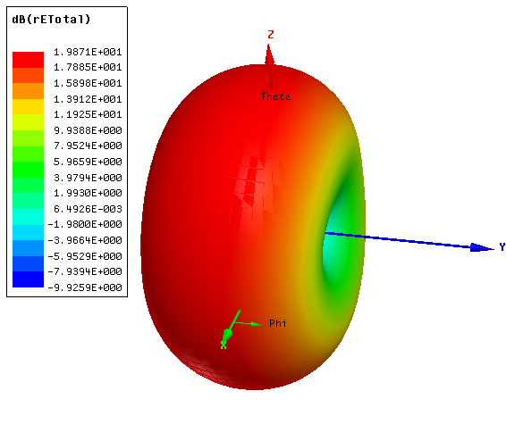

*Figure 14. The 3D gain at 2.1GHz.*

The next two figures, Figure 15 and Figure 16 show the 2D radiation fields around the antenna.

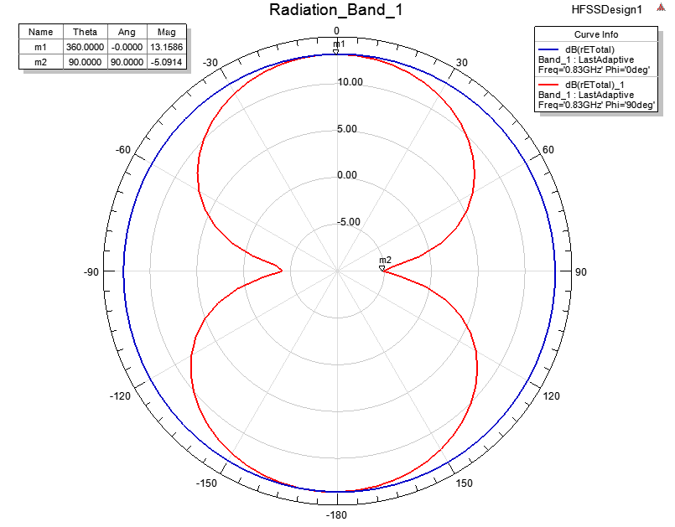

*Figure 15. The 2D radiation field at 0.8GHz.*

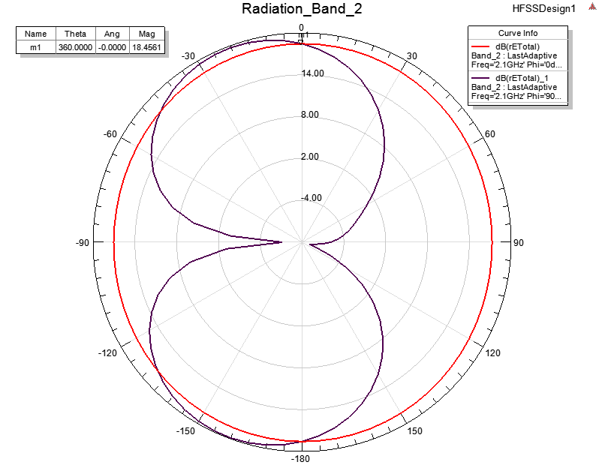

*Figure 16. The 2D radiation field at 2.1GHz.*

Villard Multiplier Circuit

The next stage in the RF energy harvesting process was to determine the design of the Villard multiplier circuit. The purpose of the Villard multiplier is to turn the small AC signal from the antenna into a DC voltage. There are 2 main characteristics that were considered in the Villard design. The first was whether a half-wave Villard multiplier was more efficient than a full-wave Villard multiplier when converting the RF signal into a DC voltage. The second characteristic was how many stages should be placed in the Villard multiplier, each stage increases the DC output voltage of the Villard multiplier. To determine what waveform Villard multiplier type would be used, a two-stage half-wave and two-stage full-wave Villard multiplier circuits were compared (Fig. 17, 18).

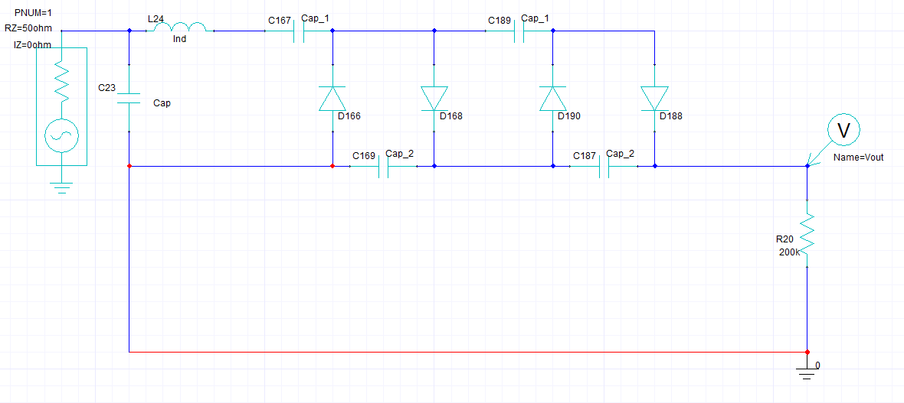

*Figure 17. Two-Stage half-wave Villard Multiplier Circuit.*

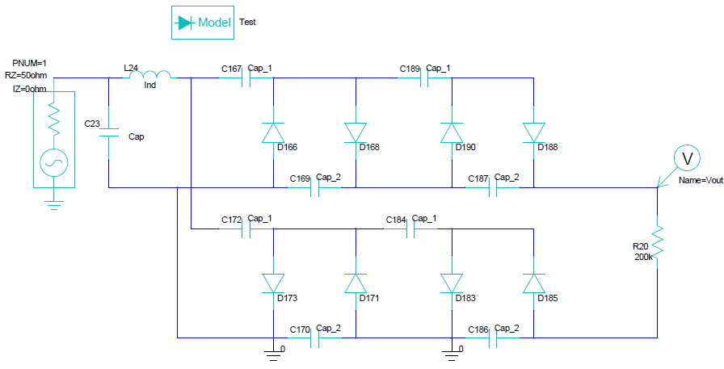

*Figure 18. Two-Stage full-wave Villard Multiplier Circuit.*

Based on the output voltages from the Ansys test results, the half-wave Villard multiplier was selected (Fig, 19, 20).

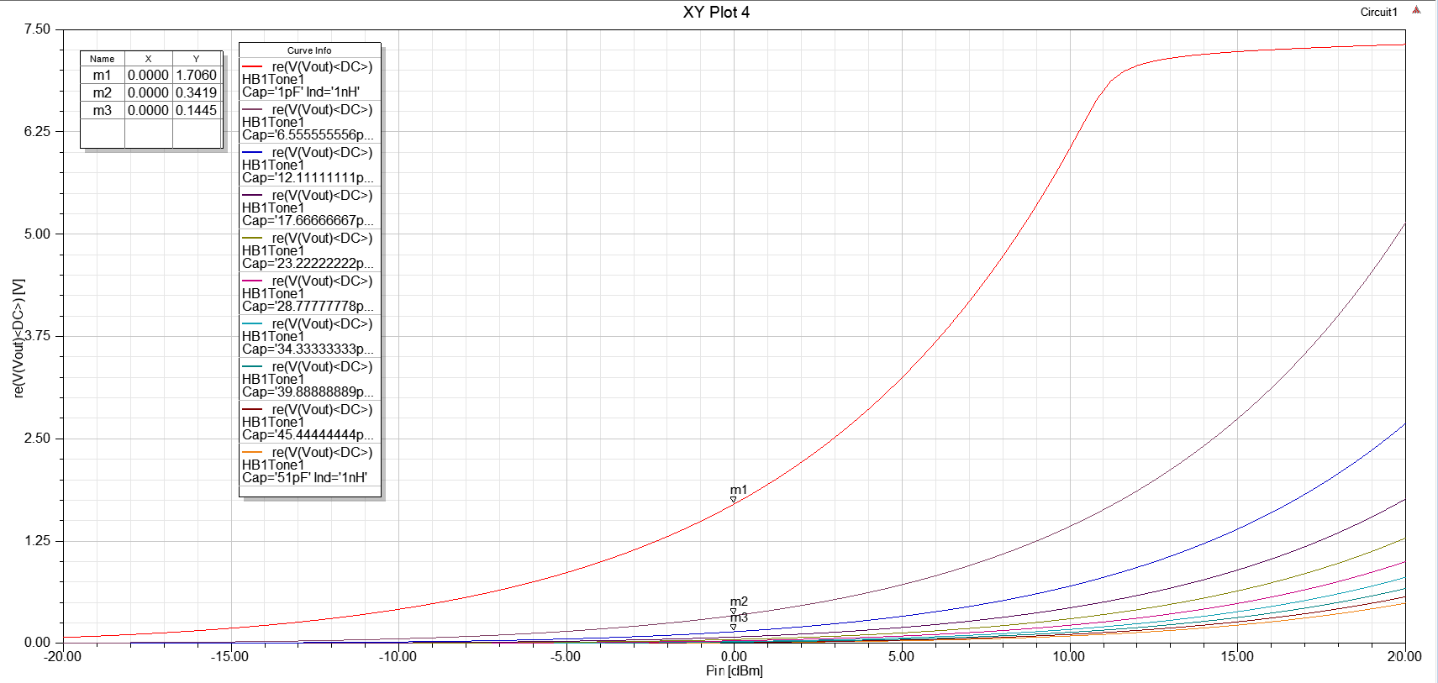

*Figure 19. Two-Stage half-wave Villard Multiplier Circuit simulation results.*

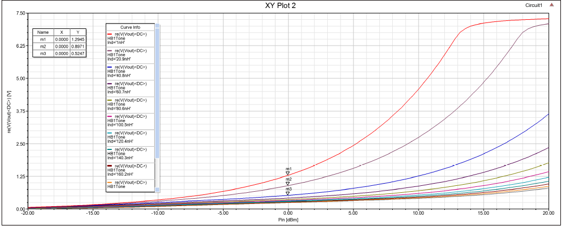

*Figure 20. Two-Stage full-wave Villard Multiplier Circuit simulation results.*

The full wave Villard multiplier results were lower than expected, the cause of the failure was the grounds added to the bottom of the full-wave Villard multiplier which is normally not required based on the design we used, but were added so Ansys could generate results.

The number of stages needed for the Villard multiplier were determined based on the simulation results from a single-stage half-wave Villard circuit at 800 MHz and 2.1 GHz (Fig. 21, 22, 23).

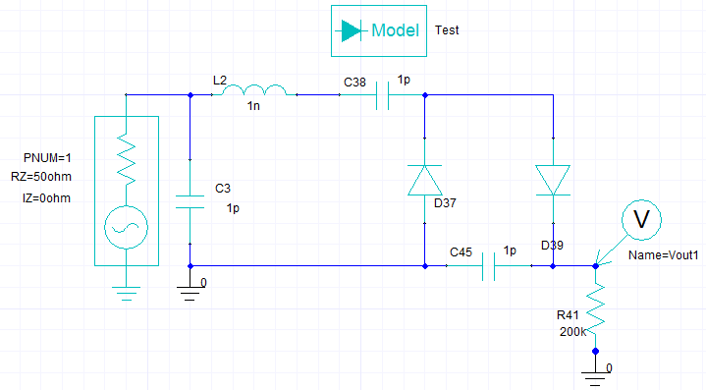

*Figure 21. Single Stage half wave Villard Multiplier Circuit.*

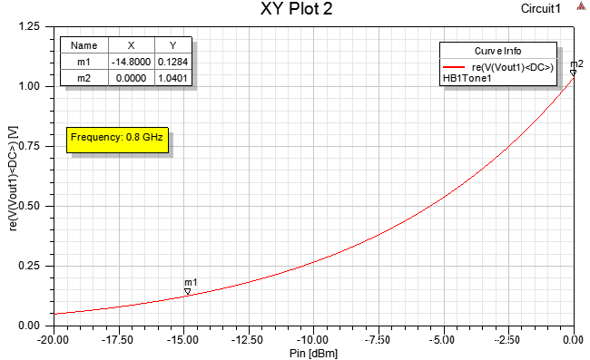

*Figure 22. Single stage analysis at 0.8 GHz.*

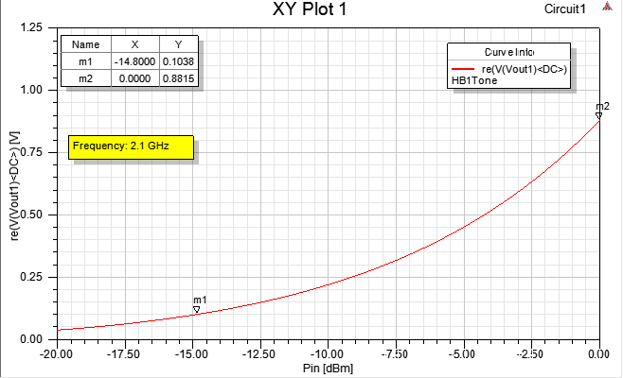.

*Figure 23. Single stage analysis at 2.1 GHz.*

The next step was to check the effect of having multiple stages on the output voltage of the circuit compared to the single-stage. Each stage consists of two diodes connected in parallel, one diode with polarity reversed with two caps in between (Fig.24).

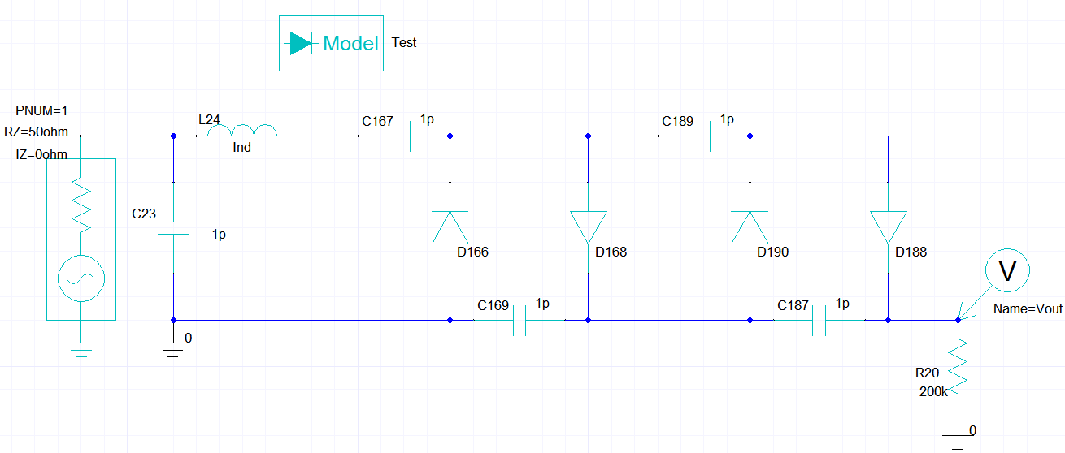

*Figure 24. Two Stages half-wave Villard Multiplier.*

Comparing the results of the two-stage versus the single-stage Villard. The comparison between the output voltages of the two-stage multiplier versus the single-stage was almost double the value of the voltage output of the single-stage rectifier at the same frequency and input power. (Fig. 25, 26).

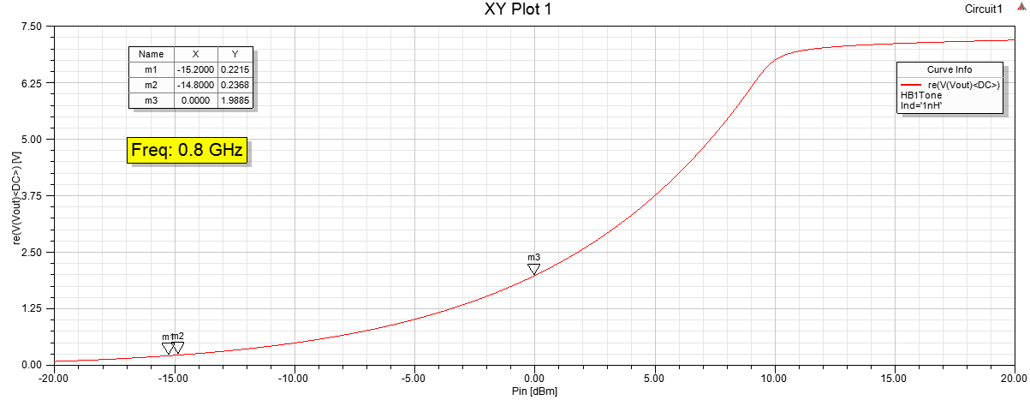

*Figure 25. Two stages analysis at 0.8 GHz.*

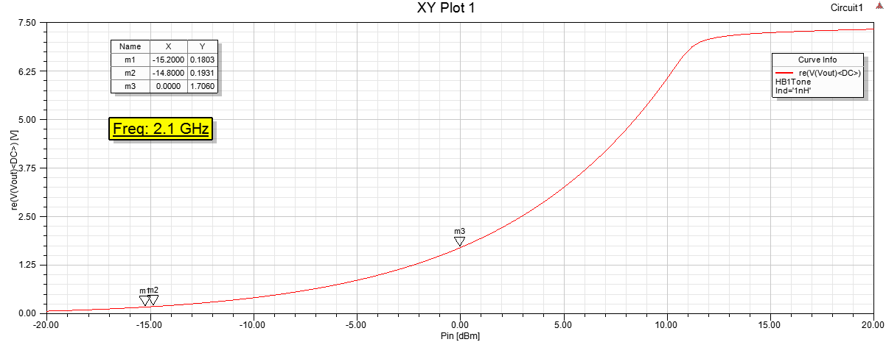

*Figure 26. Two stages analysis at 2.1 GHz.*

Based on that, it is assumed that the output voltage of a four-stage Villard would be approximately double the voltage of the two-stage multiplier (Fig. 27, 28, 29).

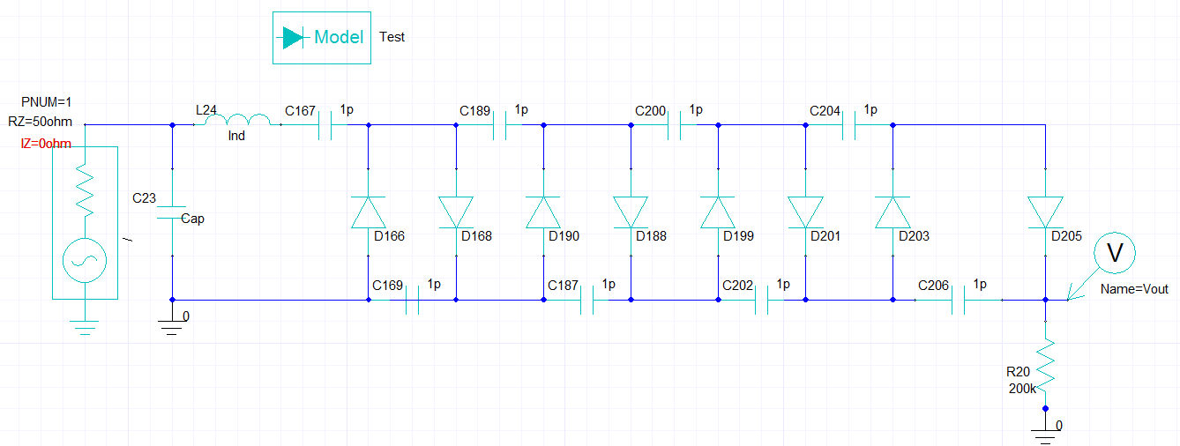

*Figure 27. Four Stages half-wave Villard Multiplier.*

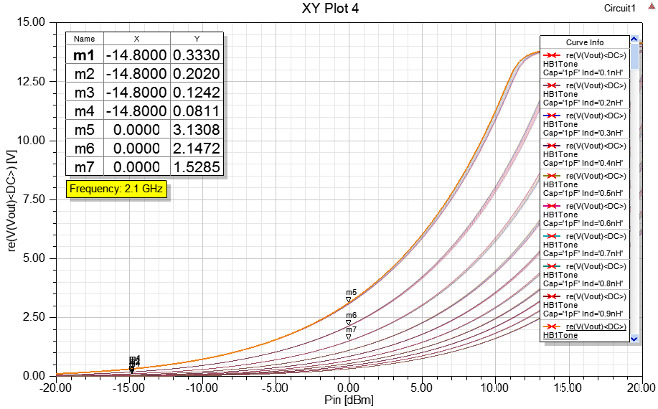

*Figure 28. Four stages analysis at 2.1 GHz.*

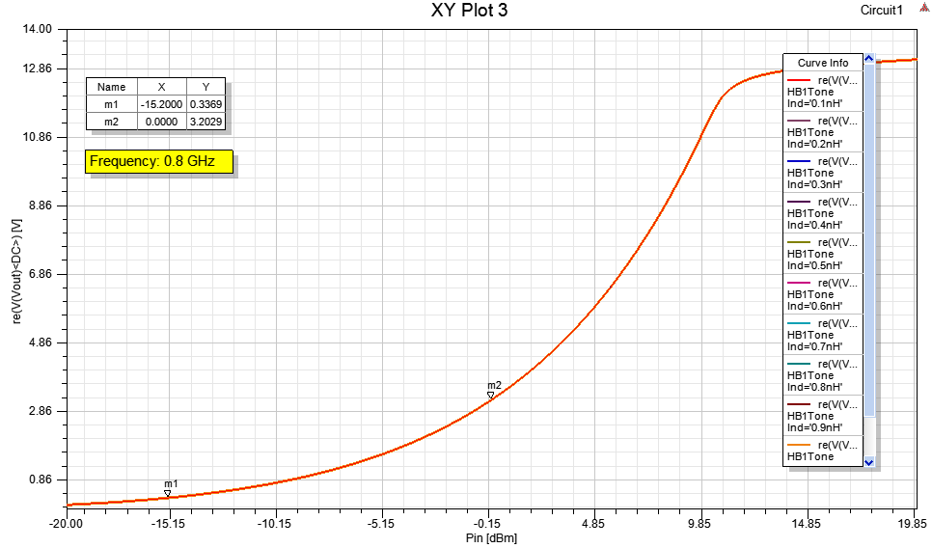

*Figure 29. Four stages analysis at 0.8 GHz.*

Based on the results the two-stage and four stage circuits were selected to be fabricated after they were optimized using the Ansys software. To optimize the circuit the software ran simulations with different component values and the simulation with the highest voltage output was selected (Fig. 30).

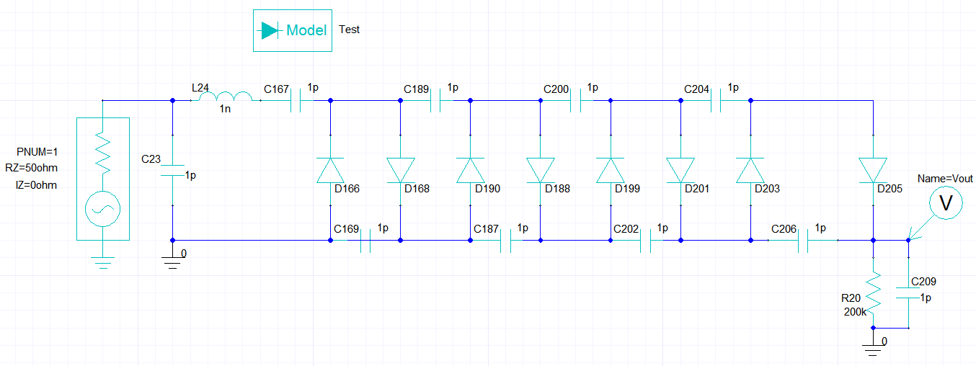

*Figure 30. Four stages final Villard multiplier optimized design.*

Matching Circuit

The energy harvesting circuit itself exhibits nonlinearity due to the nonlinear components. This implies that the impedance of the energy harvesting circuit varies with the amount of power received by the antenna. Since the maximum power transfer occurs when the rectifying circuit is matched with its antenna, the impedance matching is usually performed at the particular input power. The impedance matching unit is a resonator circuit which operates at a designated frequency to maximize the power transfer between the antenna and the multiplier as well as the efficiency. For low power applications, as is the case for collected ambient energy, there is generally not enough power to drive the diode in a high efficiency mode; hence, matching issue is essential. In the section below, the circuits of different designs of the rectifiers include the matching filters as well as a combination of a capacitor and an inductor. The designs of the matching filters were implemented using the Ansys designer in parallel with the designing of the rectifiers. Simplest matching network is L-match upward transform when the input resistance is higher than the output one.

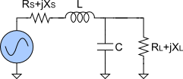

*Figure 31. Matching Circuit diagram.*

Fabrication

In order to fabricate the antenna, the design in Ansys Designer needed to be converted into a Gerber cam file which are the industry standard used for PCB (Printed Circuit Board) manufacturing. Too a PCB or antenna a minimum 5 Gerber files were required for a Two-layer part. First, a front and back copper layer, second a front and back masking layer (even if no masking is needed) and were selected. Finally, a board cut layer which shows the outer dimensions of the dielectric board. Ansys designer cannot output Gerber cam files also Purdue Northwest does not have PCB design software. Fortunately the manufacture that was selected Oshpark accepts kicad\_PCB files and Kicad is an open source PCB designer software. Kicad can also open DXF files which is one of the files that Ansys designer can export. However the drawback is that the DXF file will only show up as a drawing and all of the copper layers need to be redrawn using this drawing. After that the areas that need and do not need making must be set and the outer dimensions of the PCB must be selected for the board cuts layer. Once all the layers have been finished each layer needs to be converted into a Gerber cam file.

*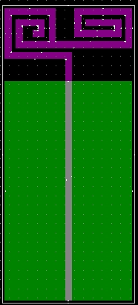*

*Figure 32. Spiral Antenna in Kicad.*

The circuit board for the Villard and matching circuits is easier to make with the Kicad software. The first step is to draw a schematic of the circuit with components from the library. The next part is to convert the schematic into PCB layout and specify the foot print for the pads on the PCB and the orientation of the pads. Then the trace size and connections are drawn between the parts, the PCB outer dimensions are selected, and finally the solder masking areas are specified. At this point the files can be converted to Gerber cam files and be sent out for manufacturing or other layers such as silk screen or drill layers can be added.

*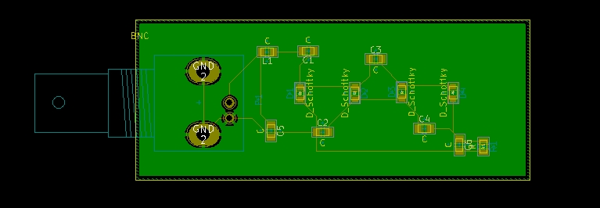*

*Figure 33. 2 stage Villard circuit PCB layout in Kicad.*

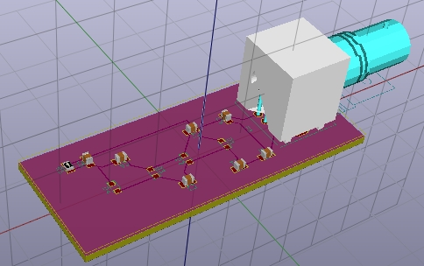

*Figure 34. A 3D model of 2 stage Villard Circuit in Kicad.*

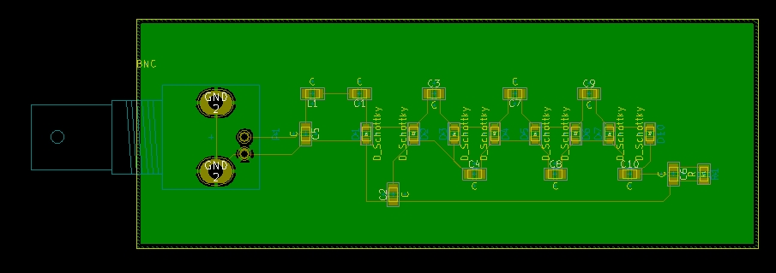

*Figure 35. 4 stage Villard circuit PCB layout in Kicad.*

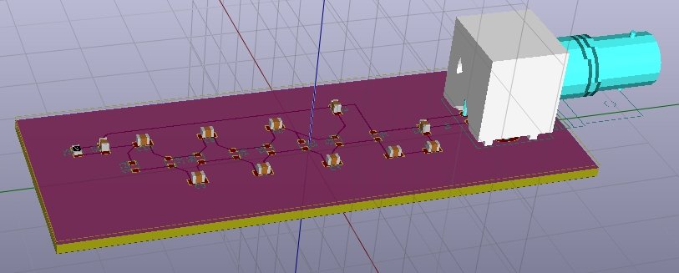

*Figure 36. A 3D model of 4 stage Villard Circuit in Kicad.*

Testing and Results

After the antenna and the rectifier had been printed and fabricated, they need to be tested for concept and functionality. The antenna can be tested using a spectrum analyzer (Fig. 32).

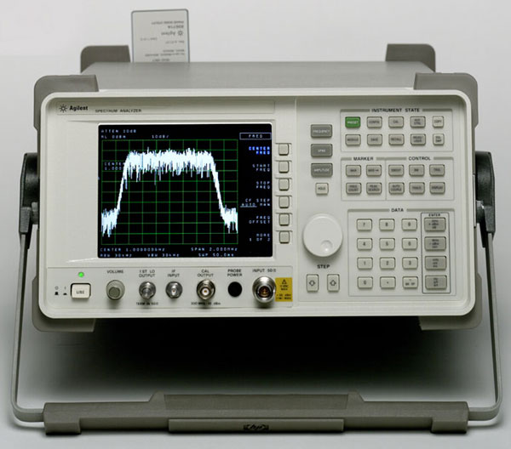

*Figure 37. Spectrum Analyzer.*

The spectrum analyzer measures the how much signal an antenna receives at particular frequencies. It measures the received power in dBm. There were some constraints and obstacles during the testing stage that the measuring instruments were placed in the basement where there is a very weak cellular signal and were unable to be moved to the outside or an open area so the antenna can get a better signal. However, a function generator was used to generate a signal at different frequencies using another antenna so the fabricated antenna can be tested with how much it can receive and what frequencies (Fig. 33).

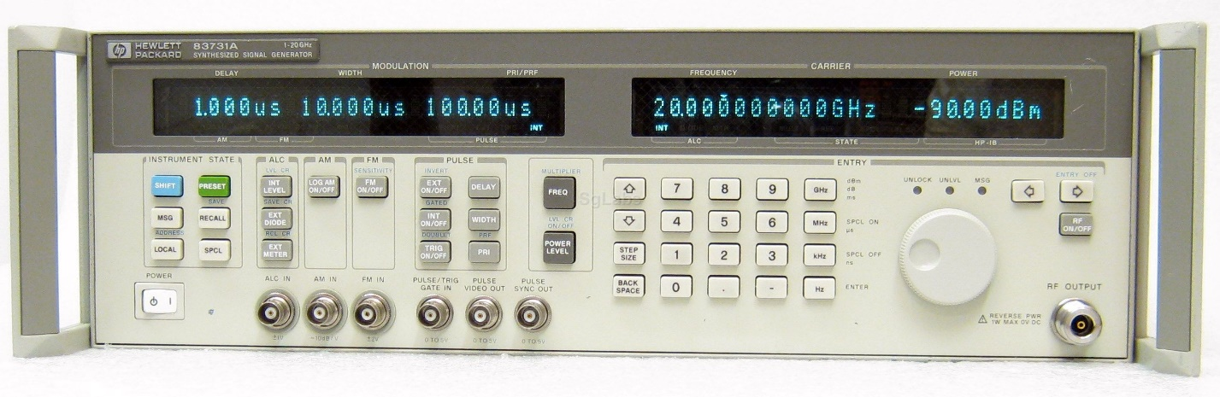

*Figure 38. High Frequency Function Generator.*

The antenna was designed to operate with dual frequencies at 0.8 and 2.1 GHz. The antenna should receive and be able to transmit a signal as well at the designed frequencies. The antenna at first was tested as a transmitting antenna. It was tested only at one frequency at its best dBm value to proof concept and functionality. It was tested and found that it best works at 1.8 GHz (Fig. 34)

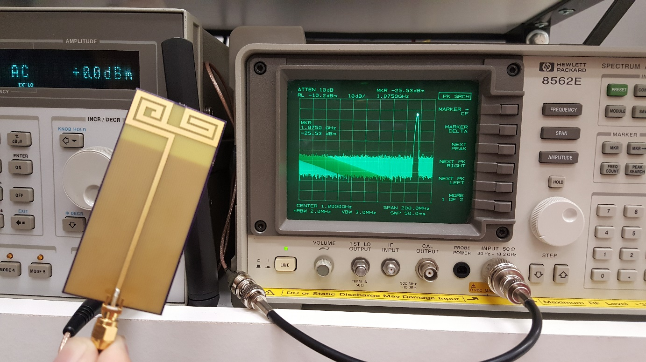

*Figure 39. Antenna tested as transmitter at 1.8 GHz.*

After that, the antenna was tested as a receiving antenna at different frequencies. It was found that the highest power received were at frequencies 0.82, 1.87, and 2.39 GHz (Fig. 35, 36, 37).

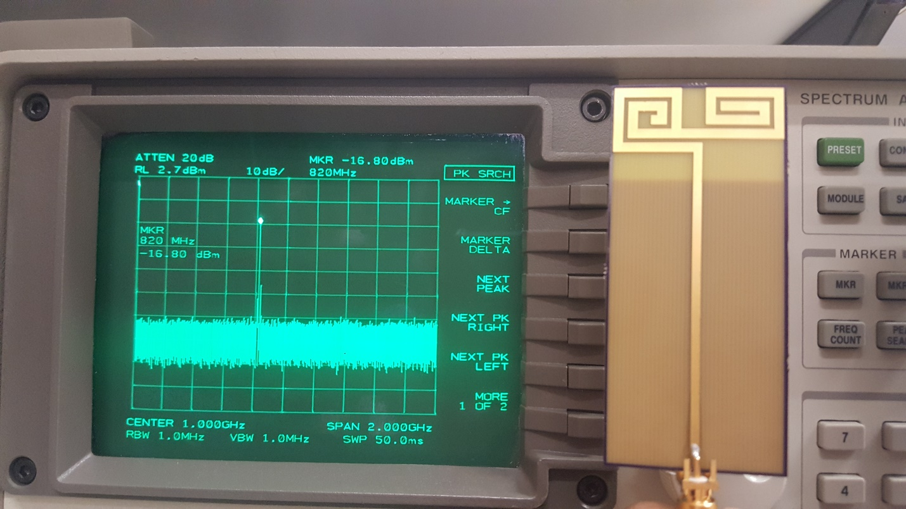

*Figure 40. Antenna receiving signal at 820 MHz.*

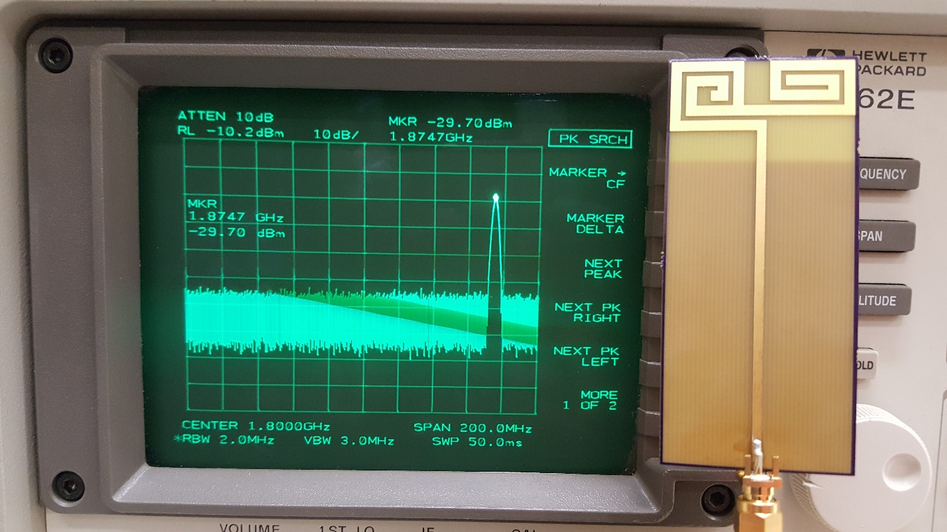

*Figure 41. Antenna receiving signal at 1.87 GHz.*

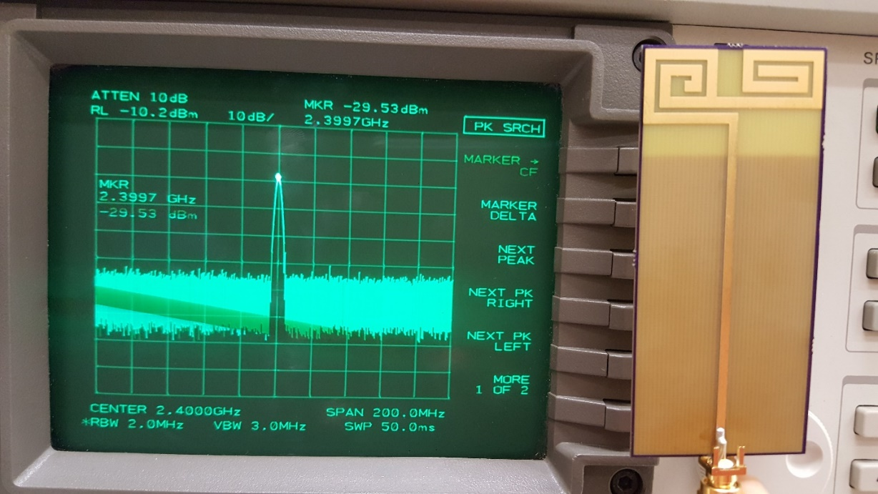

*Figure 42. Antenna receiving signal at 2.39 GHz.*

With these results, it can be seen that the working and measured values are a little different than the simulation results. The reason of such differences happened during the fabrication part of it. Because the manufacturer requested a specific file format that was not supported by Ansys, Kicad software was used where the antenna were manually redrawn where there could’ve been some measurements variations that resulted in some frequency shifting in addition to manufacturer’s accuracy and the signal loss in the cables.

The Villard circuits were tested to see their amplification abilities and at what frequencies they work best. The function generator were use in these steps to function as the receiving antenna where it was set to generate 0.0 dBm power while sweeping the frequency until finding the working frequencies. Both the two-stage and four-stage circuits were tested. The two-stage Villard got some output at higher end frequencies and very low voltage at lower frequency (Fig. 38-41).

|  |  |  |
| --- | --- | --- |
| H:\Senior design\Senior II results\20170426_163757.jpg |  | H:\Senior design\Senior II results\20170426_163726.jpg |
| *Figure 43. Two-stage at 800 MHz.* |  | *Figure 44. Two-stage at 2.1 GHz.* |
| H:\Senior design\Senior II results\20170426_163602.jpg |  | H:\Senior design\Senior II results\20170426_164141.jpg |
| *Figure 45. Two-stage at 2.28 GHz.* |  | *Figure 46. Two-stage at 2.36 GHz.* |

For the four-stage Villard circuit, the results showed that the designed circuit worked only at higher frequency but not at lower frequencies (Fig 42-45).

|  |  |  |
| --- | --- | --- |
| H:\Senior design\Senior II results\20170426_171259.jpg |  | H:\Senior design\Senior II results\20170426_171847.jpg |
| *Figure 47. Four-stage at 1.499 GHz.* |  | *Figure 48. Four-stage at 2.1 GHz.* |
| H:\Senior design\Senior II results\20170426_170808.jpg |  | H:\Senior design\Senior II results\20170426_171732.jpg |
| *Figure 49. Four-stage at 2.25 GHz.* |  | *Figure 50. Four-stage at 2.37 GHz.* |

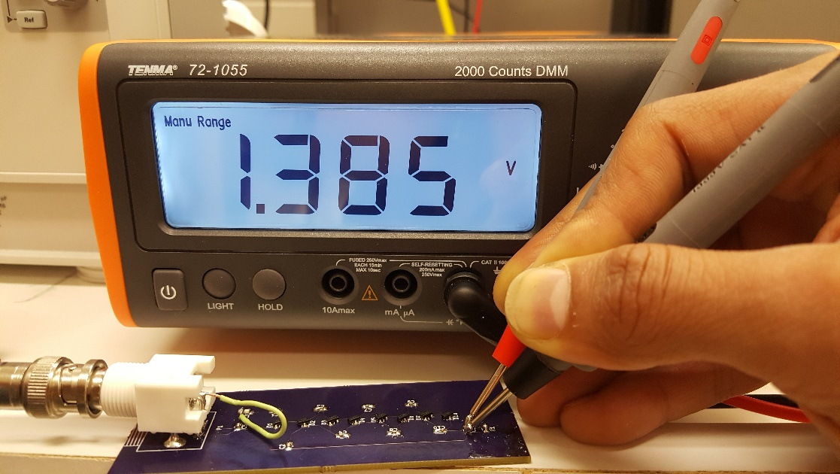

*Figure 51. Four-stage at 2.44 GHz.*

By putting the results of the antenna measurements side by side with the measurements of the Villard circuits and comparing them, it can be noticed that there were discrepancies between the simulation resluts and the measured values. Despite that the measurments generally showed that the antenna and the villard worked at different frequencies, they both conceptually worked as they intended to, but with some variation from the simulation. The shift in frequency in the villard circuit could be caused by many different reasons. One of the reasons could be the value of the capacitor and the inductor in the filter. The values of the components from the simulation software might not be the best for the targeted frequencies, despite the simulation results. The tolerance of the components also might have affected the operation of the circuit resulting in frequency shift. Another reason was the power loss in the signal. The soldering past in the antenna and the villard circuit acts as a transmitting antenna which led in some losses.

Conclusion and Recommendation of Future Work

A single band dipole antenna was designed and simulated using Ansys Electronic desktop to operate at 0.8 GHz. Then, to extend the efficiency of the harvester, the antenna design was modified to spiral antenna structure and simulated to function as a dual band antenna at 0.8 and 2.1 GHz. The adopted antenna was simulated using an HFSS simulation tool and implemented on AutoCAD. The Villard multiplier circuits were all able to convert the RF signal into a DC voltage. However the circuits did not properly function in the frequency range that was simulated in the Ansys software.

In the future more work must be done to eliminate the frequency variation issues in the Antenna and Villard multiplier circuits. Also an increase in the antenna size can assist in the amount of power harvested. Increasing the number of antennas harvesting from multiple different frequencies would increase the power as well.

References

1. D. Pavone, A. Buonanno, M. D’Urso, and F. D. Corte, “Design considerations for radio frequency energy harvesting” Progress In Electromagnetics Research B. Vol. 45. Pp. 19-35. 2012.

Appendix: Time Line

